**1**

Label the pictures using the words in the box

Trousers – socks – shoes – t-shirt – cap – shorts – skirt – shirt – jacket – uniform

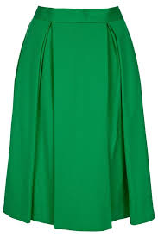

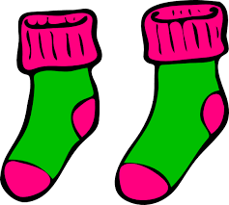

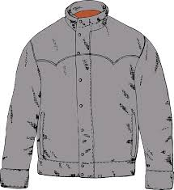

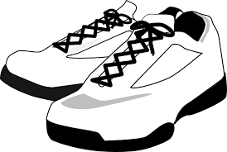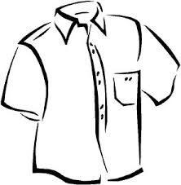

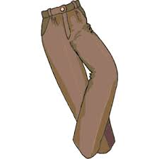

**2**

Color the following clothes.

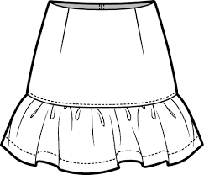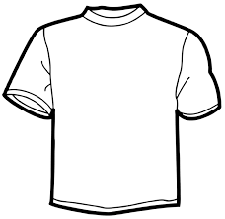

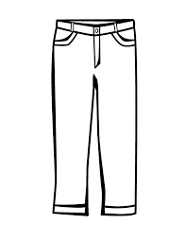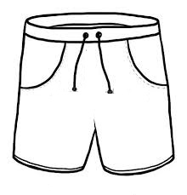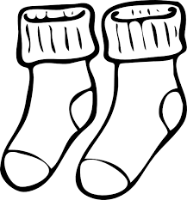

What are these kids wearing? Write as in the example

**3**



This is Zoey. She is wearing red T-shirt, blue skirt, white socks and black shoes

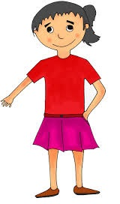

This is Syaina. She is wearing ………

…………………………………………………………………..

……………………………………………………………………

They are Daniel and Daniela. Daniel is wearing ………………………………………………

…………………………………………………………………………………………………………………………………………

Daniela is wearing …………………………………….

……………………………………………………………………………………………………………………………………………………

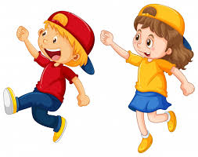

 Read the sentences and color the pictures

Hello. My name is Thomas. Today, I’m wearing blue t-shirt, yellow shorts, brown socks and green shoes.

How about you? **What are you wearing today?**

**4**